Experimental Results--No.5

Total Time：120 min

1. Use Case Diagram

Time：5 min

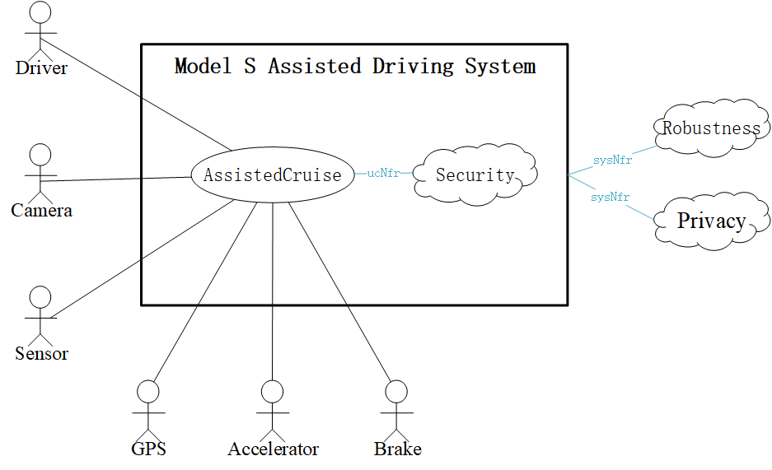

1. System Sequence Diagram

Time：70min

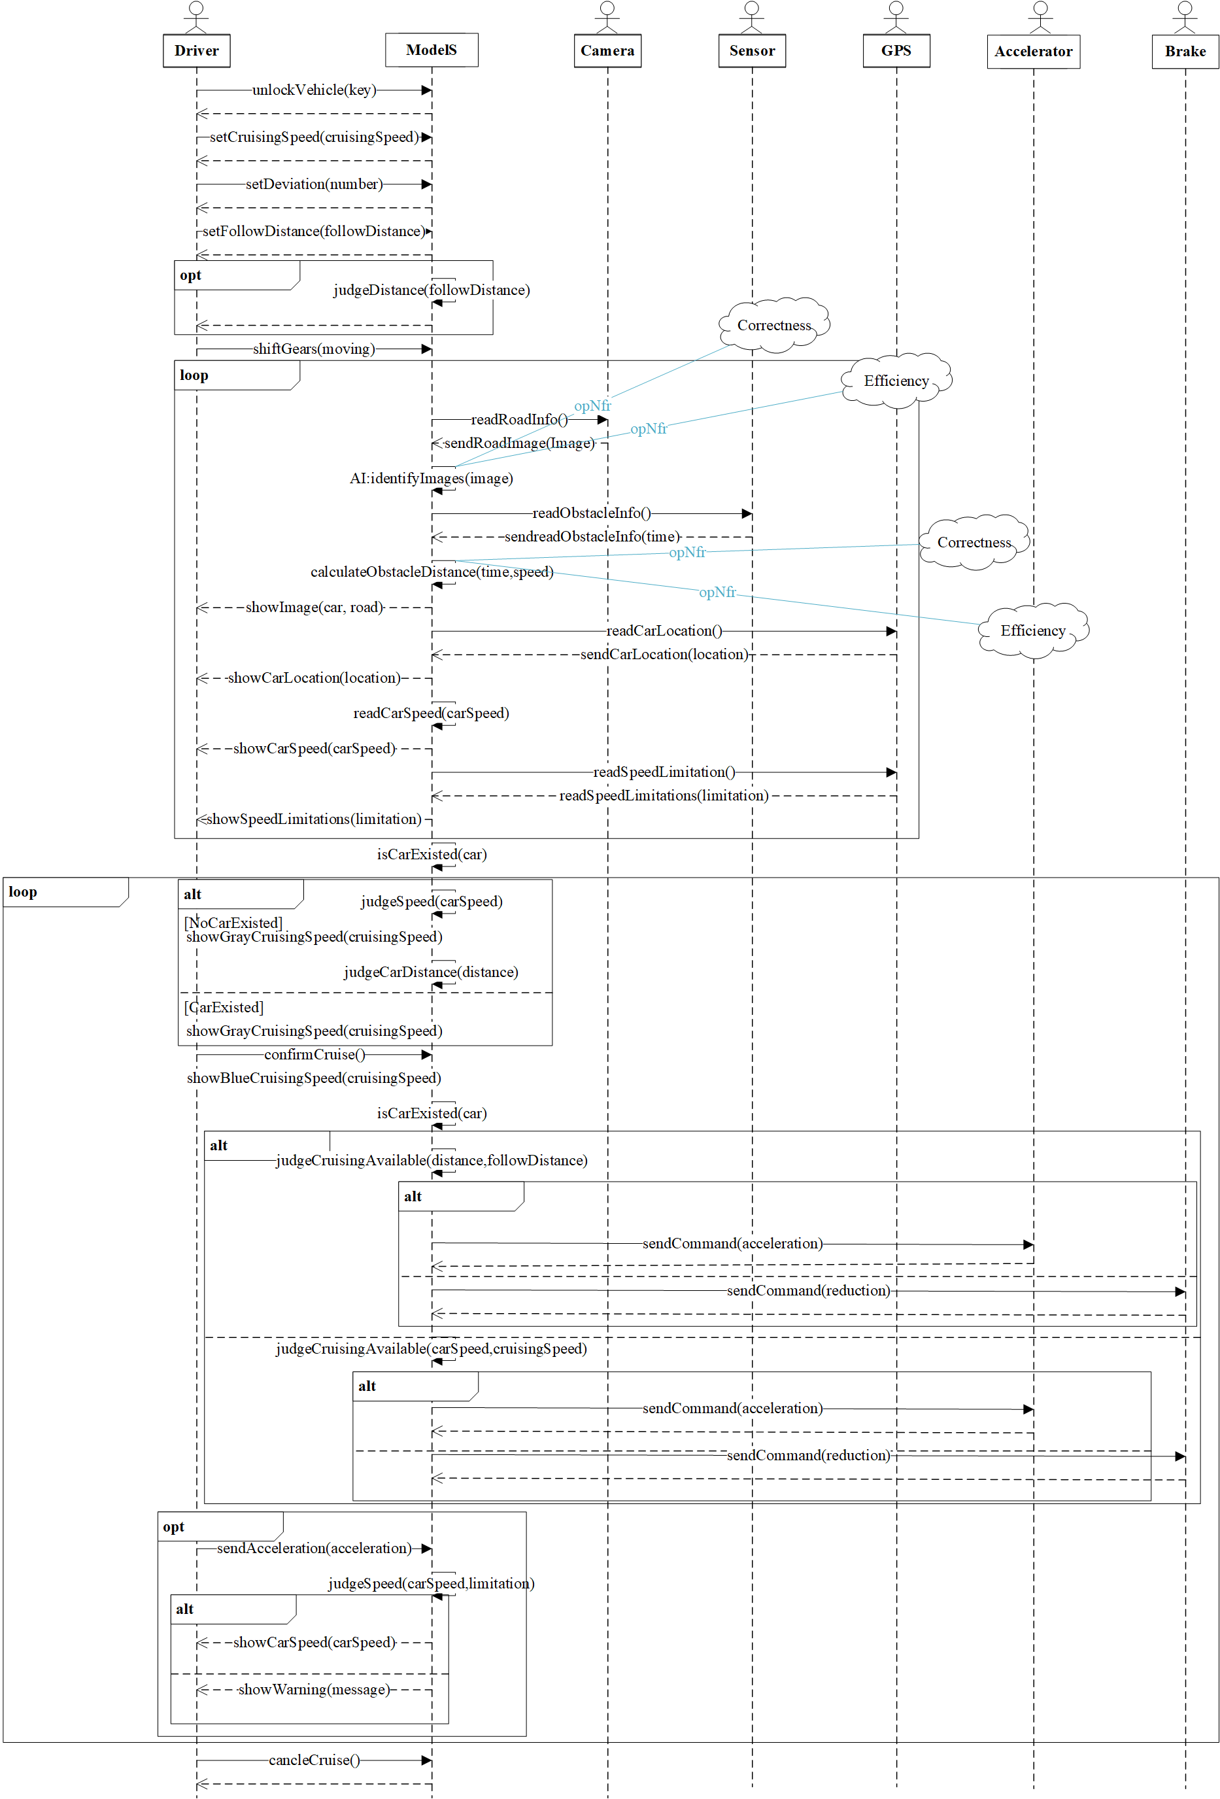

1. Conceptual Class Diagram

Time：20min

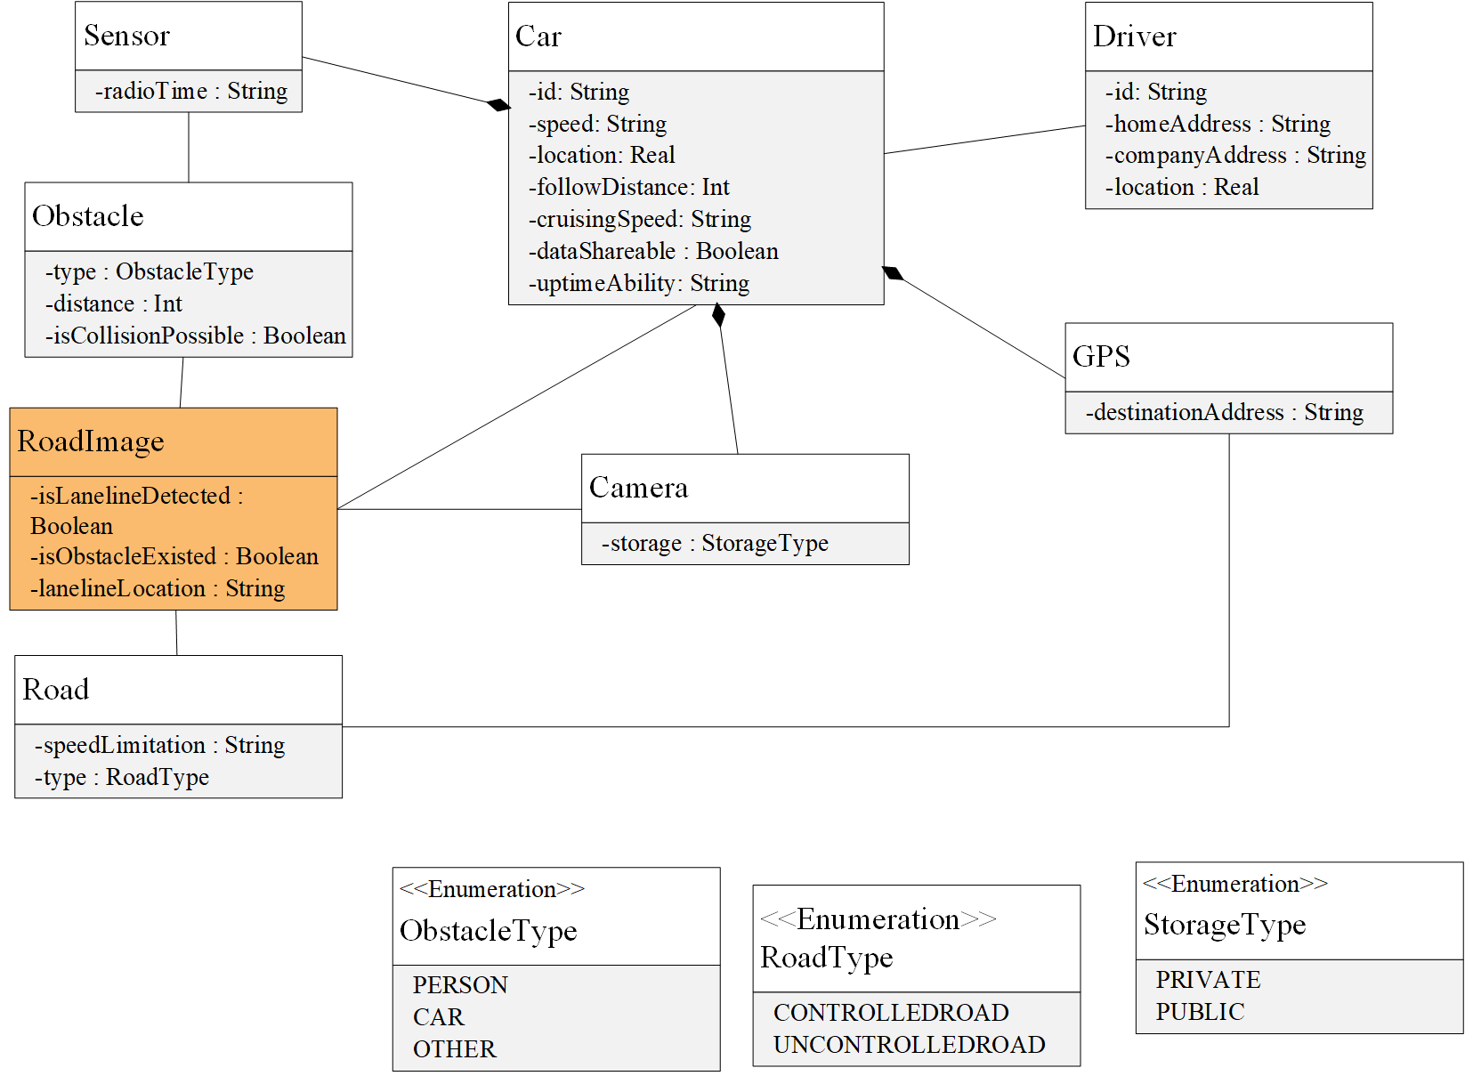

1. Context Diagram

Time：15min

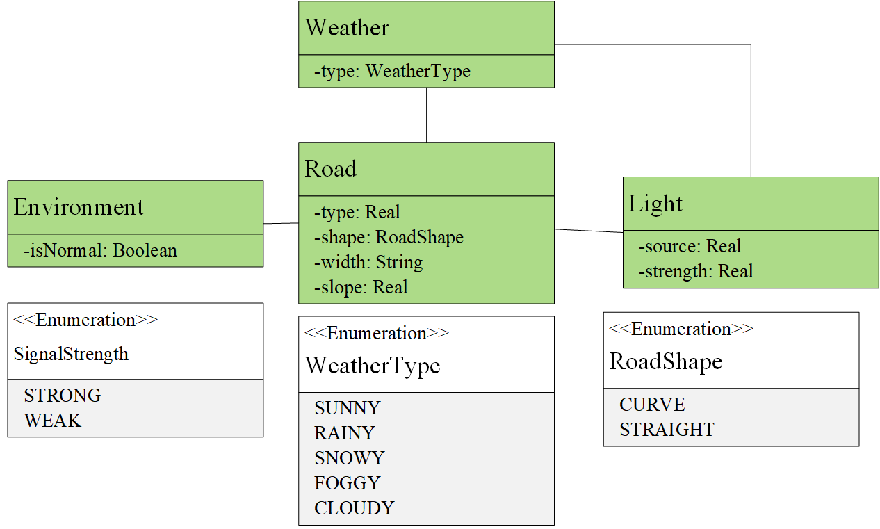

1. Machine Learning Diagram

Time：10min

